**Computer Systems Architecture**

1. Explain the difference between a client-server network and a peer-to-peer network.
2. Thinking in terms of systems allows us to analyze situations that are too complicated for us to understand as a whole. What specific characteristics and features of system thinking make this possible?
3. The figure below shows the basic architecture for a three-tier database system. This system can be viewed as an IPO (input-processing-output) system. What is the input for this system? What environmental element generates the input? (Hint: the Web browser computer is within the system boundary.) What is the expected output from this system? What environmental element receives the output? Briefly describe the processing that takes place in this system.

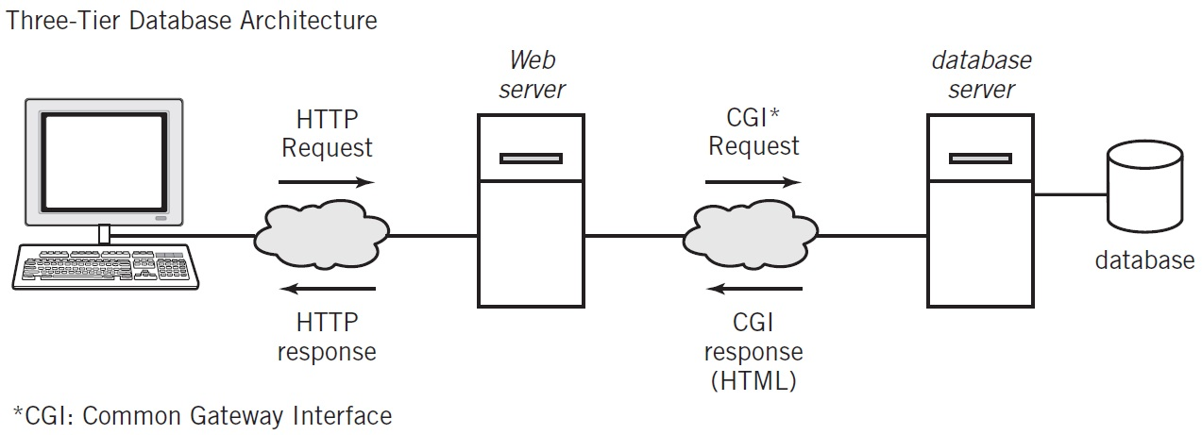

1. Based on the illustration of an iPhone shown in the figure below, draw a system model for an iPhone

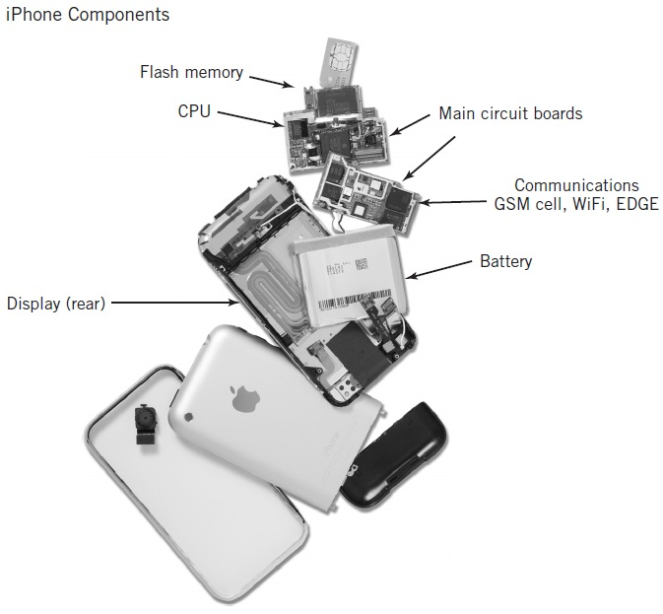

1. Suppose that you have been hired to develop a website-based sales system for a large international retail sales firm. Discuss some environmental issues that are specific to the Web design of your system that you must consider if your system is to be successful at attracting and keeping purchasing customers.